- Use the ping command to test the connectivity to a remote server (e.g., example.com).
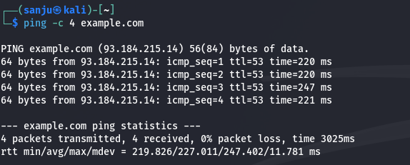
- Write a script to measure the round-trip time for each packet and analyze the results.
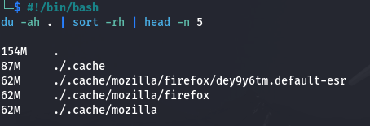
- Use the traceroute to trace the route packets take to a destination
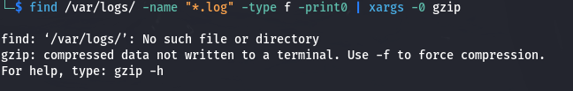
- Analyze the output to identify any potential bottlenecks or points of failure in the route.
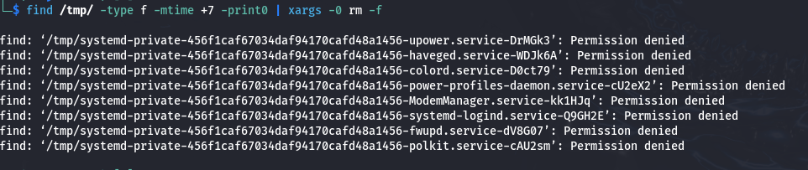
- Use the nslookup command to find the IP address of a given domain (e.g., example.com).

- Use the netstat command to view active connections and listening ports on your machine.
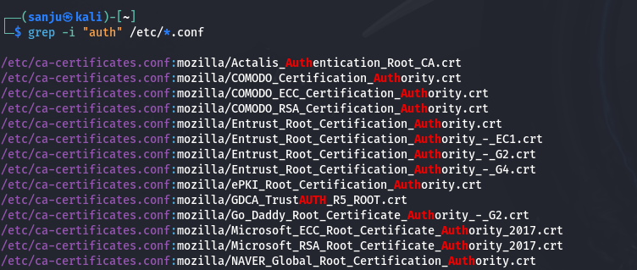
- Use the ifconfig (Linux) or ip a command to display network interface configurations.

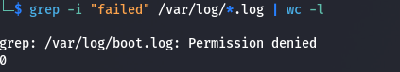
- Write a script to report document the configuration of each interface, noting the IP address, subnet mask, and any other relevant information.

- Perform a basic network scan using nmap on your local network to identify active devices and open ports.
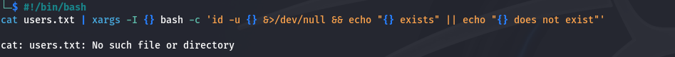
- Create a report summarizing the devices found, their IP addresses, and the services running on the open ports.
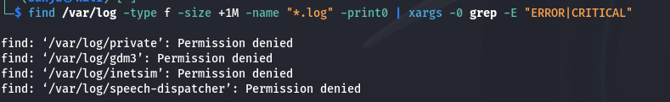
- Capture network packets using tcpdump on a specific interface.
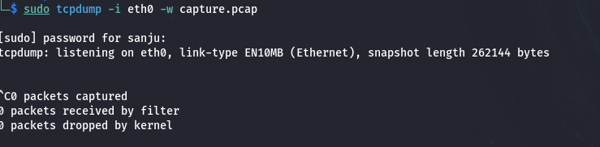
- Analyze the captured packets for specific protocols (like HTTP or DNS) and summarize your findings.
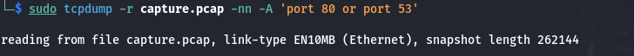
- Use the whois command to gather registration information about a domain.
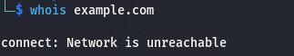
- Use the hostname command to display and change the hostname of your machine.
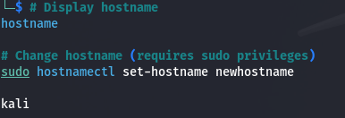
- Use the finger command to gather information about users on a system.
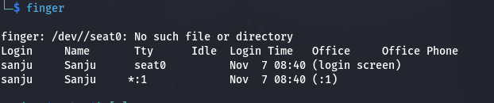
- Use the who command to see who is currently logged into the system and the last command to view the login history.
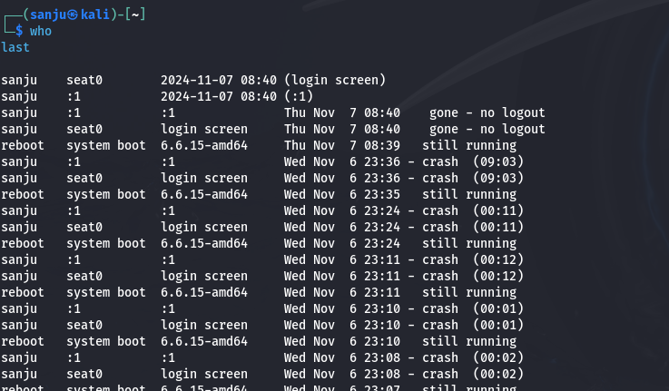
-------------------------------------------------------------------------------------------------------------------------
Xargs
-------------------------------------------------------------------------------------------------------------------------
- Write a shell script called testurl.sh that accepts a list of urls in a separate file and tests if the website is up or not.
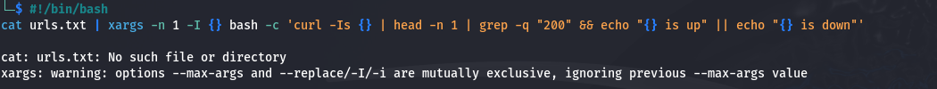
- Create a shell script called diskhog.sh that lists the 5 largest items (files or directories) in the current directory in decreasing order of size.
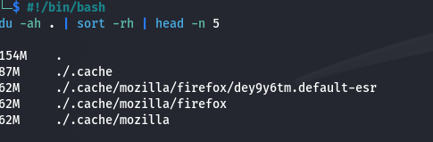
- compress all .log files found in the /var/logs/ directory?
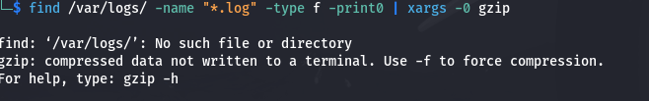
- delete all temporary files older than 7 days from the /tmp/ directory?
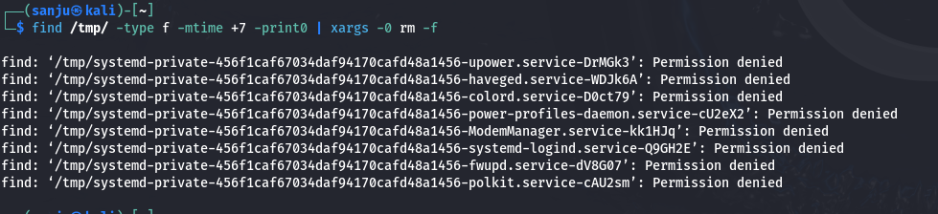
- write a shell script to make all .sh files in your home directory executable?
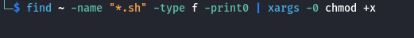
- search for the string "auth" in all .conf files in the /etc/ directory
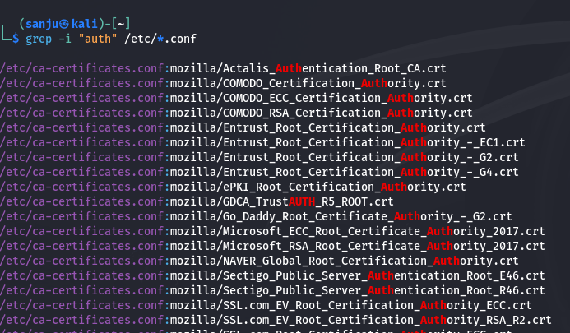
- count the number of "failed" login attempts in all .log files in /var/log/?
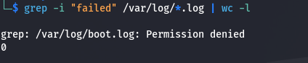
- rename all .txt files in the current directory by appending .bak

- Write a shell script to check if a list of users from users.txt exist in the system.
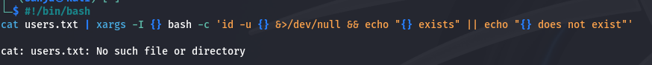
- search for keywords like "ERROR" or "CRITICAL" in all log files over 1MB in size.
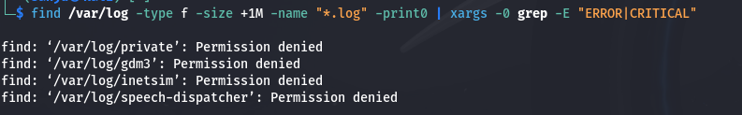
=================================================================================================================================================================
“If everyone is moving forward together, then success takes care of itself.” — Henry Ford

